

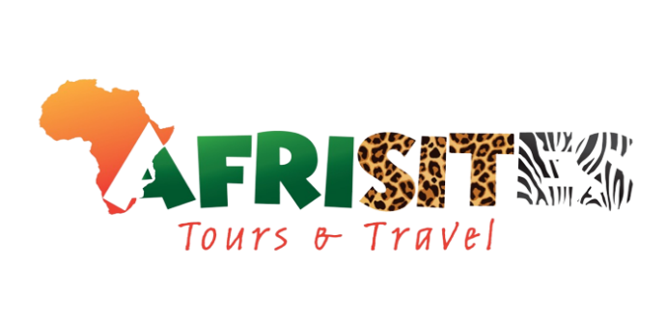





www.afrisitestoursandtravel.org info@afrisitestoursandtravel.org
+256393101000
Kiira Division, Buwate, Lightclose

12-Day Eastern & Northern Uganda Discovery Safari
Culture • Waterfalls • Heritage • Wildlife
Tour Style: Mid-Range | Relaxed Pace | Scenic & Cultural
Operated by: Afrisites Tours & Travel
Overview:
This journey takes you across Eastern and Northern Uganda, blending cultural heritage, dramatic waterfalls, ancient rock art, and classic savannah wildlife. Designed at a relaxed pace, the itinerary allows time to explore, rest, and fully experience Uganda beyond the usual safari routes.

DAY 1: Arrival in Kampala
Arrive at Entebbe International Airport and meet your professional safari guide. Transfer to your hotel in Kampala for rest and trip briefing.
Overnight: Mid-range hotel, Kampala
Meals: Dinner

DAY 2: Kampala → Sezibwa Falls → Jinja
Travel east to Sezibwa Falls for a guided cultural and nature experience. Continue to Jinja, Uganda’s adventure capital. Afternoon at leisure.
Overnight: Mid-range lodge, Jinja
Meals: Breakfast, Lunch, Dinner

DAY 3: Jinja Cultural Tour & Busowoko Falls
Enjoy a guided cultural tour in Jinja, engaging with local traditions and history. Boat Cruise at the Nile then Visit Busowoko Falls for some activities and photography and relaxation. Evening at leisure.
Overnight: Mid-range lodge, Jinja
Meals: Breakfast, Lunch, Dinner

DAY 4: Jinja → Sipi Falls
Scenic drive to Sipi Falls through eastern highlands. Arrive in the afternoon and enjoy a gentle nature walk with panoramic views.
Overnight: Mid-range lodge, Sipi
Meals: Breakfast, Lunch, Dinner

DAY 5: Sipi Falls – Full Day Experience
Guided hike to the three Sipi waterfalls at a comfortable pace. Optional coffee and cultural experience. Afternoon free for rest and photography.
Overnight: Mid-range lodge, Sipi
Meals: Breakfast, Lunch, Dinner

DAY 6: Sipi → Nyero Rock Paintings → Soroti
Drive to Nyero Rock Paintings, a UNESCO-listed heritage site in Kumi. Continue to Soroti for overnight.
Overnight: Mid-range hotel, Soroti
Meals: Breakfast, Lunch, Dinner

DAY 7: Soroti → Northern Uganda (Aruu Falls)
Travel north to Aruu (Ru) Falls in Pader District. Explore the falls and enjoy light cultural interaction with the local community.
Overnight: Lodge / guesthouse, Northern Uganda
Meals: Breakfast, Lunch, Dinner

DAY 8: Northern Uganda – Culture & Leisure
A relaxed day to explore Northern Uganda’s culture, village life, and landscapes. Ideal for rest and cultural immersion.
Overnight: Lodge / guesthouse, Northern Uganda
Meals: Breakfast, Lunch, Dinner

DAY 9: Northern Uganda → Murchison Falls National Park
Drive to Murchison Falls National Park, Uganda’s largest and most dramatic park. Afternoon at leisure overlooking the Nile.
Overnight: Mid-range lodge, Murchison Falls NP
Meals: Breakfast, Lunch, Dinner

DAY 10: Murchison Falls – Game Drive & Nile Cruise
Morning game drive on the northern plains in search of lions, elephants, giraffes, buffaloes, and antelopes. Afternoon boat cruise on the Nile to the base of the falls, followed by a guided hike to the Top of the Falls.
Overnight: Mid-range lodge, Murchison Falls NP
Meals: Breakfast, Lunch, Dinner

DAY 11: Murchison Falls – Leisure Day
A relaxed day for optional activities such as bird watching, photography, or a second game drive. Time to unwind and enjoy the lodge.
Overnight: Mid-range lodge, Murchison Falls NP
Meals: Breakfast, Lunch, Dinner

DAY 12: Murchison Falls → Kampala
Return to Kampala with lunch en route. Drop-off at hotel or Entebbe International Airport for departure.
Meals: Breakfast, Lunch

INCLUSIONS
- Private comfortable vehicle (Supa-Custom / 4x4) with experienced driver-guid
- 11 nights accommodation in mid-range lodges / guesthouses (twin share).
- Meals as indicated Days 2–11: Breakfast, Lunch & Dinner.
  - Exception: Dinner on the final day (Day 12) is NOT included. Extra accommodation + dinner in Kampala can be added at extra cost.
- Park & site entry fees as per itinerary (Sezibwa, Nyero, Sipi guide fees, Murchison park & Nile boat cruise).
- Local guides at key sites; English-speaking driver-guide for the full tour.
- One Nile boat cruise (Murchison) + hike to the Top of the Falls + one full game drive in Murchison.
- Bottled water during transfers, local taxes & service charges.

EXCLUSIONS
- International / domestic flights, visas and airport taxes.
- Personal items, alcohol, laundry, phone calls, tips.
- Optional activities not listed (rafting, quad biking, private photographer).
- Final day (Day 12) dinner unless extra accommodation purchased.

Group Size | Solo (1) | 2 people | 3 people | 4 people | 5 people | 6 people
Retail Price Rates | $5,650 | $3,450 | $2,880 | $2,600 | $2,375 | $2,175

